Create a Private Amazon S3 Bucket

Objectives :-
After completing this lab, you will know how to:-
- Create a bucket in Amazon S3
- Add an object to a bucket
- Manage access permissions on an object and a bucket
- Create a bucket policy
- Use bucket versioning

Step 1: Navigate to Amazon S3
- Log in to your AWS Management Console.
- In the search bar, type S3 and select Amazon S3 from the results.
- You will land on the S3 home page. Click Create bucket to begin.
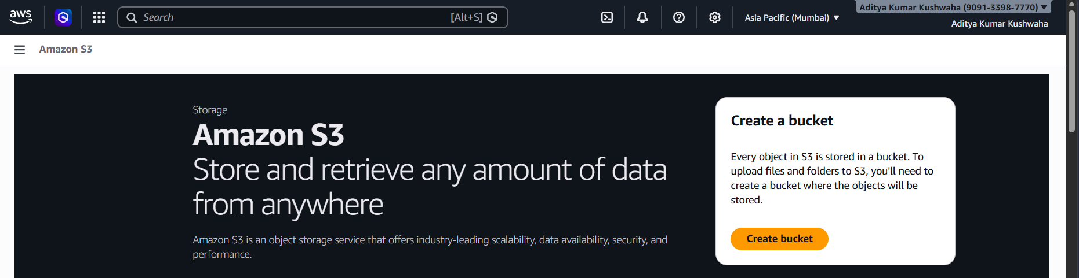

Step 2: Configure Bucket Type and Name
On the Create bucket page, configure the following settings:
- Bucket type: Select General purpose.
- Bucket name: Enter aws-ad-bucket. Names must be 3–63 characters, lowercase, with letters, numbers, hyphens, or periods.
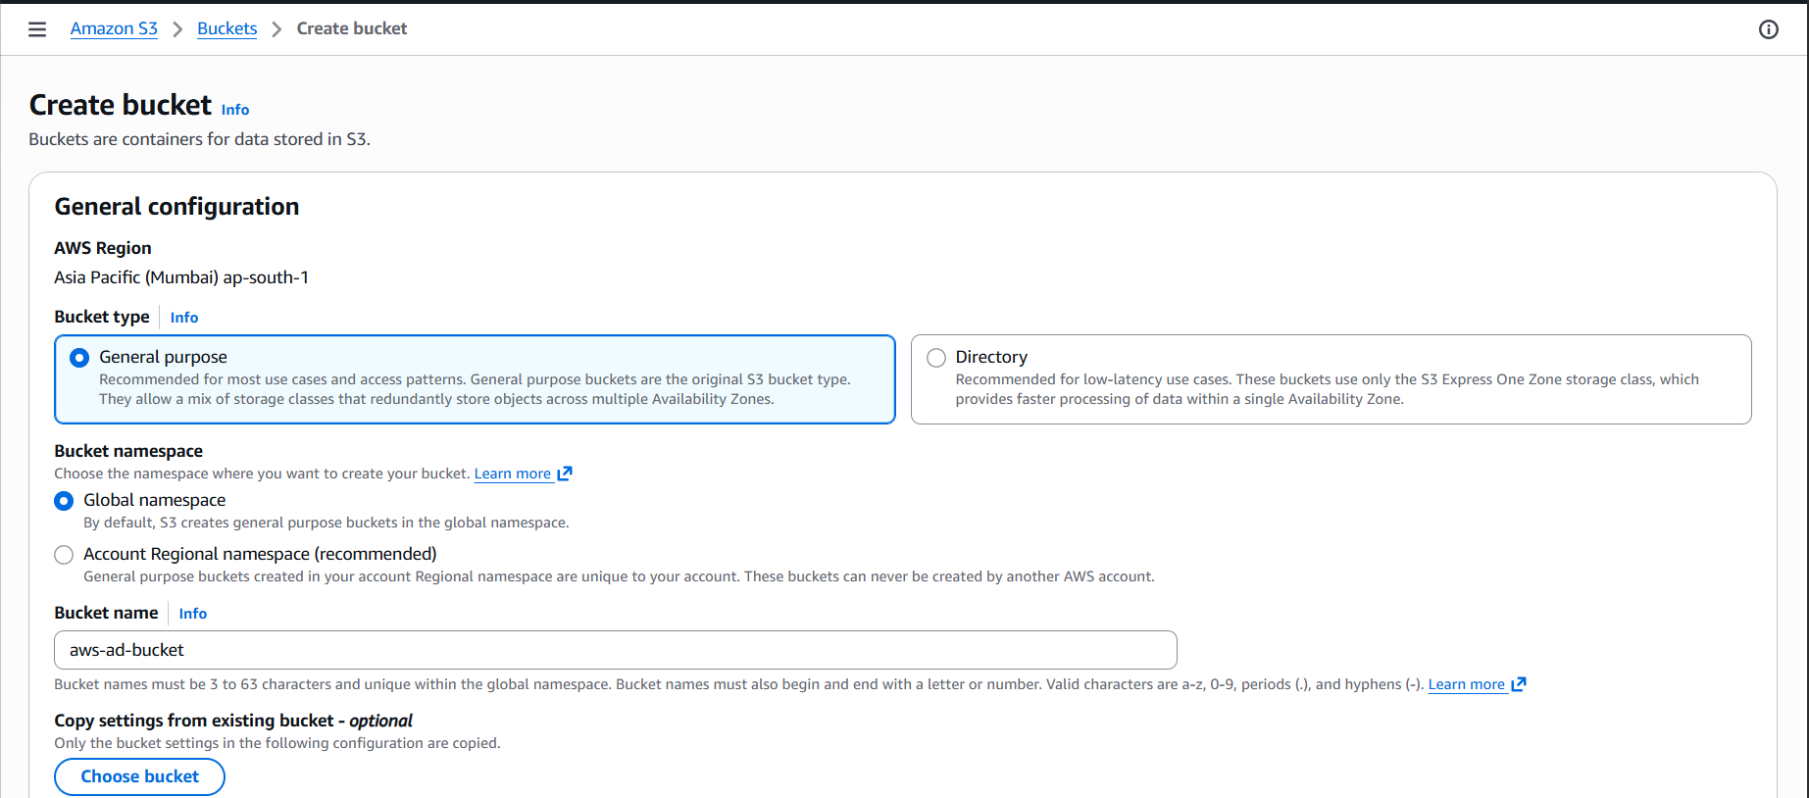

Step 3: Set Object Ownership
Scroll down to the Object Ownership section:
- Select ACLs disabled (recommended). All objects are owned by your AWS account.
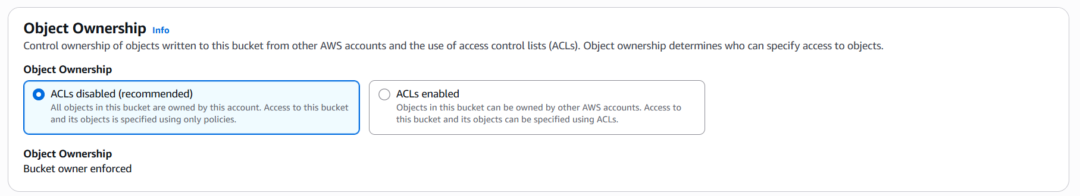

Step 4: Block All Public Access
This is the critical step to ensure the bucket remains private:
- Check the box for Block all public access.
- This ensures that no public access is granted to the bucket or its objects.
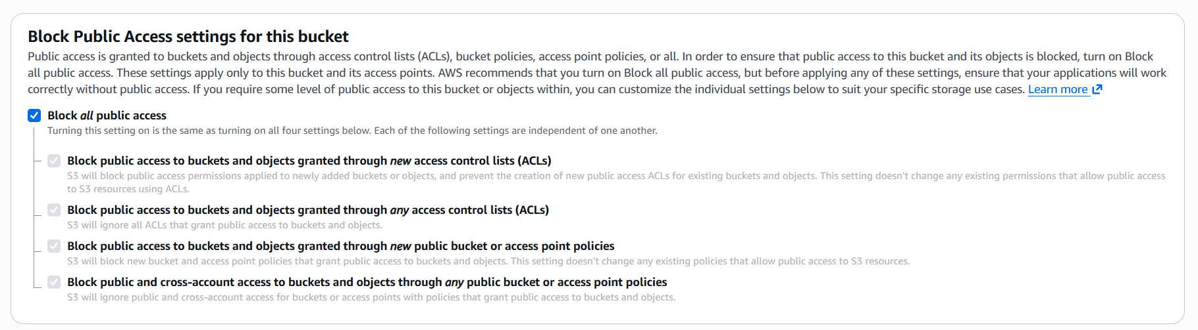

Step 5: Configure Default Encryption
Scroll to the Default encryption section:
- Enable server-side encryption (SSE-S3) to secure stored data.

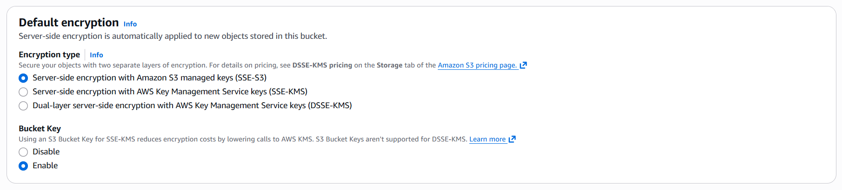

- Click Create bucket to finalize.

Step 6: The Bucket's Dashboard
Open your private bucket aws-ad-bucket in Amazon S3 to access its dashboard, where you can manage objects, check properties, and control access securely.
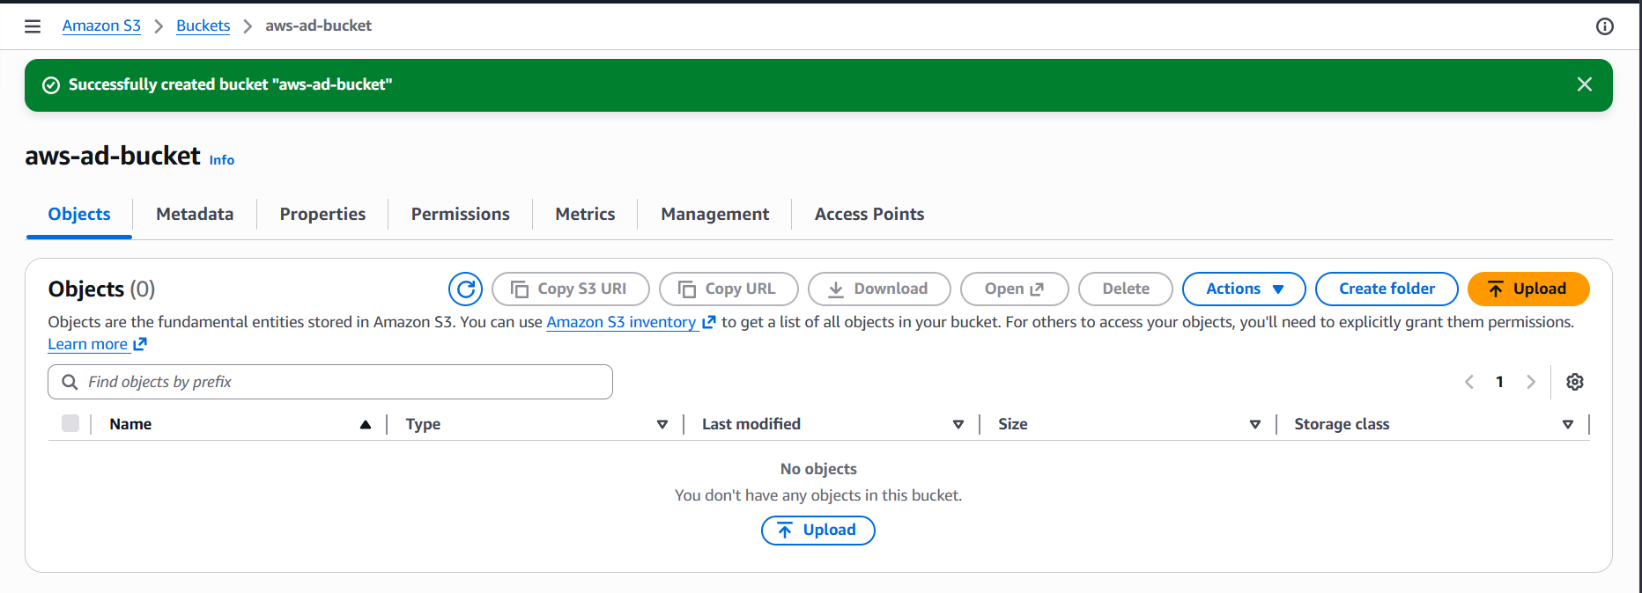
Step 7: Upload a File to the Bucket
After the bucket is created, upload your files:
- Navigate into your bucket (aws-ad-bucket) and click Upload.
- Drag and drop files, or click Add files / Add folder to browse.
- Selected files will appear in the Files and folders list.
- Confirm the Destination bucket and click Upload to complete the process.
